**1**

*What is the title of the visualization?*

Who’s in Your Wallet?

*Who created it?*

Story, Data, & Design: Alejandra Arevalo, Eric Hausken. Code: Jeff MacInnes

*Where is the visualization from?*

Taken from The Pudding, a digital publisher which produces data journalism for storytelling.

*What data does it use?*

Banknotes around the world, including 236 unique banknotes from 38 countries.

*What is the purpose of visualization?*

the purpose is to describe who are the characters that appear on the bills. but beyond that (because that is the purpose of the article) the first visualization, which is a horizontal bar chart, has two objectives, the first is to provide dynamism and interaction to the user since each horizontal column has points that represent each banknote. When you put the mouse over it you get the represented character's name and the photo if available.

The second is to provide information beyond the graph: the chart, as it initially comes, shows the distribution of characters by professions and accomplishments, but then, as the user scrolls down the page, the colors of these points change to describe other types of statistics or interesting insights which are presented as dynamic pop-ups, e.g who are the most outstanding writers, the political women represented, or who are monarchs.

*How is the visualization composed? What charts are used?*

In addition to the graph described in the previous section, three more are presented later:

* the first is another horizontal bar chart where the Notable “Firsts” Honored on Banknotes are indicated, by country (where the colors represent the gender). In this, there are no pop-ups but when you put the mouse on each block next to the country the characters appear and in which they were the first.
* The second is about the distribution of bill values by gender, in which we are presented with dot plots in which the character appears when we select each point. Also, there are no pop-ups, and the information is limited to the initial graph.
* The last one is a reversed bar chart which uses lines instead of bars, and each line represents either: i) how many years between death and appearance on the banknote being each line a character and both edges the year when he died (left) and the year when that person appeared in the banknote; or ii) how many years some people (10) were alive while they appeared on a banknote. This is also dynamic and changes the color of the lines and the zoom of the graph to highlight new information that appears through pop-up messages, as the user scrolls down the page.

*Does the visualization have a clear message? Who is the intended audience?*

The target is the general population, anyone who is concerned about the characters that appear on the bills. The message is clear, although he speaks of historical figures, the author always tries to be very concise in the reason for his relevance. As the graphics are dynamic, not only for free exploration but also required to advance in the story told by the author, they generate a more active connection with the reader, which can be engaging.

*Is the visualization effective? Why/why not?*

Yes, it presents information clearly, effectively, and efficiently. In the first and last graphs, the author, in addition to relying on graphs that are easy to read and familiar to most people (horizontal bar charts), uses pop-up messages as the graphs change to highlight or identify what these messages are telling you, so they not only present you with the graph, but they also analyze it for you.

*How would you change the visualization to strengthen the message?*

I think that the choice of color, although it obeys a certain convention of using sepia tones to talk about past or historical information, I don't like it, I would prefer something “clearer” and with less yellow. On the other hand, regarding the choice of typography, most of the text uses something like Times New Roman, which is fine for the mood of the article, but in the titles and charts, modern font is used which seems ugly to me and does not match with the rest of the article.

*Link*

<https://pudding.cool/2022/04/banknotes/>

*Screenshots*

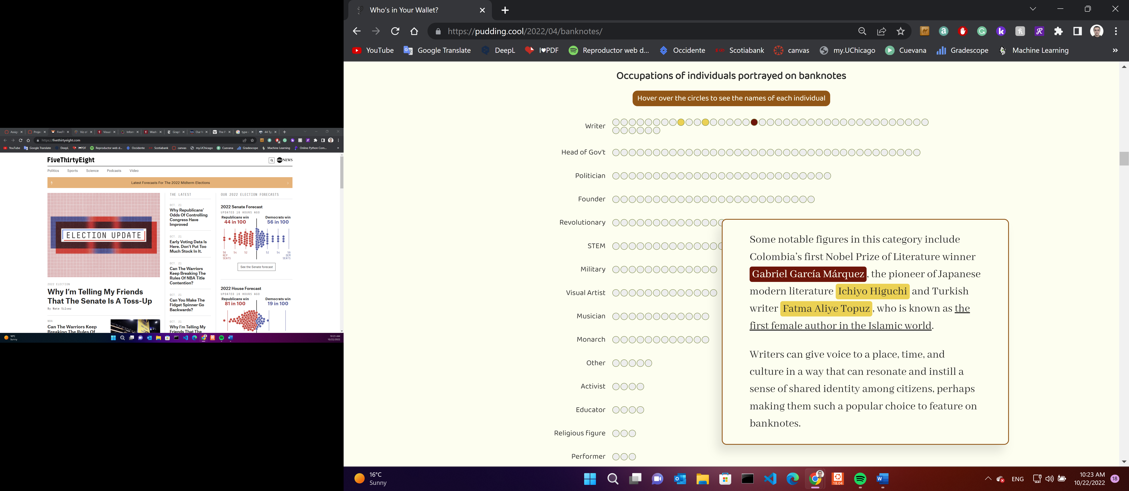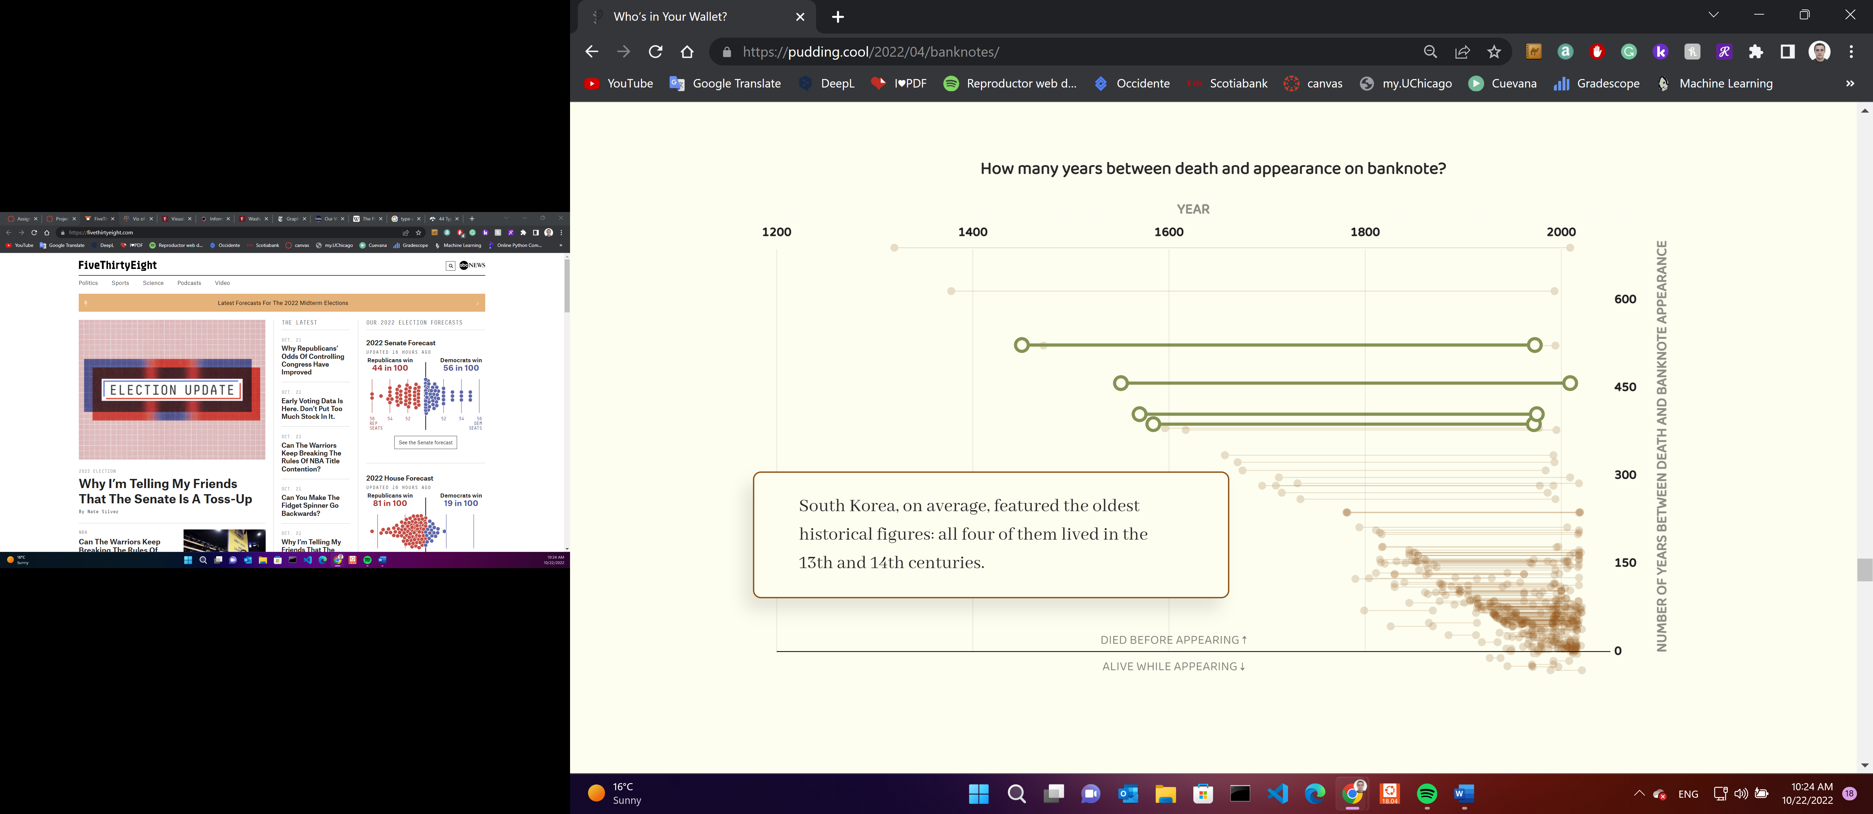

**2**

*What is the title of the visualization?*

What was the worst Best Picture?

*Who created it?*

Bo McCready (@boknowsdata)

*Where is the visualization from?*

Taken from Tableau Viz of the Day.

*What data does it use?*

Academic awards for best picture (nominations and winners) between 1928 and today.

*What is the purpose of visualization?*

Both present the results of this competition and contrast their results with the public opinion extracted from another source (IMDb).

*How is the visualization composed? What charts are used?*

We are presented with two vertical timelines, with the most recent information at the top. The first presents the official results of the awards (the nominees in blue and the winners in brown) where the x-axis is the user rating on IMDb, and the size of each circle denotes the number of user votes. The second is similar but they are not Oscar-nominated movies.

*Does the visualization have a clear message? Who is the intended audience?*

No. Although the target audience is anyone with some notion of movies, I have the feeling that the author is only throwing a lot of information at you at the same time, but not telling you a story and not even giving this information in a friendly manner.

*Is the visualization effective? Why/why not?*

No, the chart is everything but user-friendly. For example, the colors of the circles (if the movie is nominee or winner) are deduced after reviewing the subtitle of the graph (but it is not something that I immediately figured out since the main title also has words in various colors) there is not a clear indication in this regard.

The graphs are very long, and at first, it is not straightforward to distinguish between the information provided by the x-axis and the size of the circles.

The parallel graph, which shows other outstanding films not nominated for this award, although its purpose is to provide additional information to the left chart, it uses a different format on the y axis which is confusing at first glance (an improvement would be copying or extending the format of the graph on the left to make the comparison more natural). Also, this additional graph has no x-axis.

Finally, although the texts within the graphic seek to highlight some movies, there are many and you don't know why they are highlighted (there is no story to follow). Moreover, some circles are cut which is ugly.

*How would you change the visualization to strengthen the message?*

I think that a better approach is to define a story to tell, a couple of messages, and take the reader across the graph around these messages. For example, I would highlight situations in which there were more popular films than those that reached the Oscars, and if the information is available, explain why otherwise leaving the question to the reader so that they get engaged.

In the end, if the author still wants to let people explore the data on their own, throw all the data as it is now, but after presenting him with some insights so the user can easily navigate.

*Link*

<https://public.tableau.com/app/profile/bo.mccready8742/viz/WhatwastheworstBestPicture/TheWorstBestPicture>

*Screenshot*

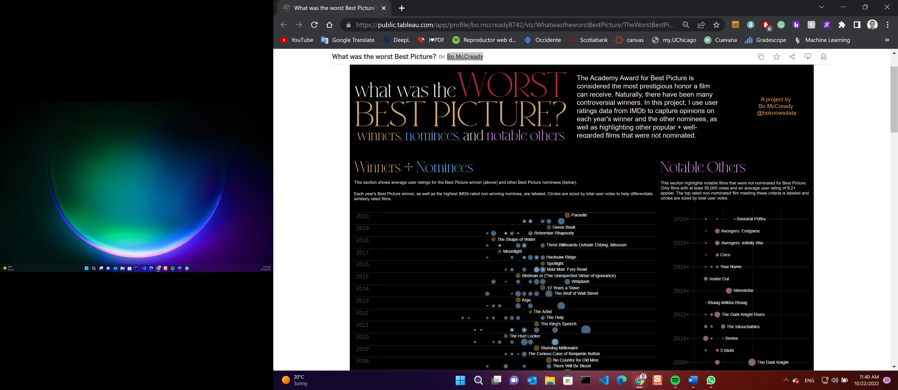

(…)

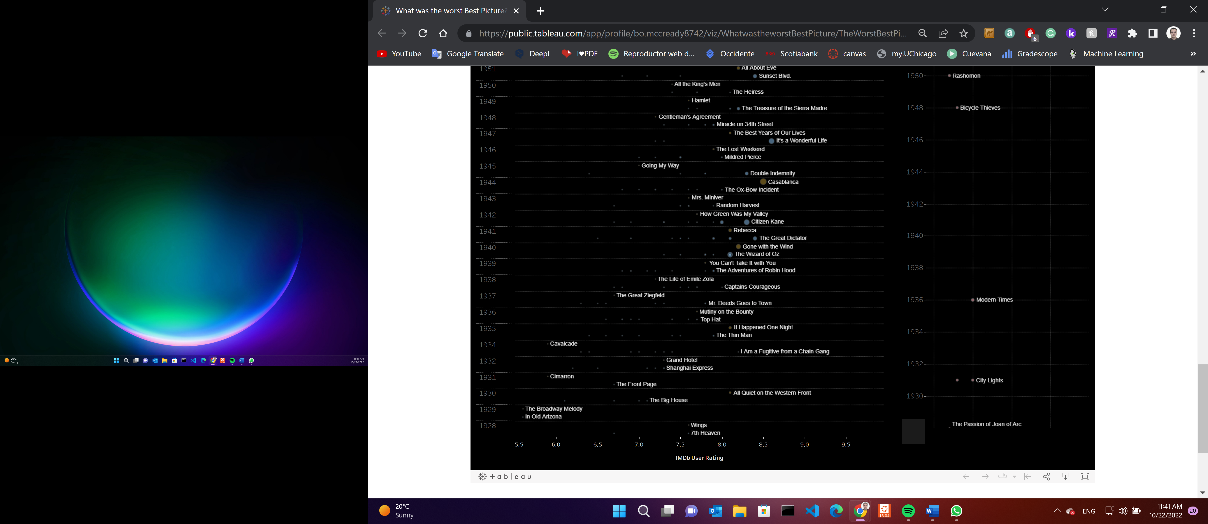

**3**

*What is the title of the visualization?*

% Renewable Electricity by Country

*Who created it?*

Research & design: David McCandless Additional research: Dr Stephanie Starling Code: Tom Evans, Paul Barton

*Where is the visualization from?*

Taken from *Information is Beautiful* web page.

*What data does it use?*

Renewable electricity usage (as a percentage of total energy usage) by country, the state within the US, and by type of renewal energy. Data from the US Energy Information Administration (EIA.org)

*What is the purpose of visualization?*

Identify the countries or states within the US that are most committed to the use of clean energy, and those that are not. They are presented using maps that allow regional patterns and comparisons between countries to be easily identified.

*How is the visualization composed? What charts are used?*

The authors use three interactive choropleth maps: for the entire planet, the US, and Europe. They use a color scale to differentiate the use of renewable energy as a proportion of the total usage in each geographic unit, which goes from red for the least committed areas, to blue for the places that stand out for their exceptional use of clean energy. However, instead of making a continuous color transition, the authors choose to separate the data into quintiles, which speeds up the comparisons. Although this decision loses the comparison within each category, it is compensated by also presenting the percentages.

*Does the visualization have a clear message? Who is the intended audience?*

Yes, consider that the discrete color scale leads the reader to identify which areas need the greatest commitment to the use of renewable energies, and which areas excel in this task and should be followed. The message is simple and direct.

Although the objective is the general public, basic notions of geography are required which surprisingly are not as widespread as one would like to think.

*Is the visualization effective? Why/why not?*

Yes, it is clear and simple. However, my assessment may be biased because I really like maps. Although the authors present you with a lot of information, I consider they correctly use colors and zooms (in the case of the US and Europe) to carry you to the conclusion and quickly identify regional patterns, which is their goal.

*How would you change the visualization to strengthen the message?*

I would put more information in the additional information that is displayed when you put the cursor over a country/state since the percentage is already in the graph. This would enrich the additional exploration that the user can do. Also, some highlights within the plot also could be useful to remark on and/or point out some interesting findings (for example, the worst/best cases).

*Link*

<https://informationisbeautiful.net/visualizations/renewable-energy-and-electricity/>

*Screenshots*

